DAY 1 -02/02/2026 Introduction
The first class began with a self-introduction session, followed by an overview of the Wellness Chatbot project and its objectives.
WellBot – Global Wellness Assistant is an AI-powered chatbot designed to provide personalized health guidance, mental wellness support, and basic medical assistance to users worldwide.
DAY 2 – 03/02/2026 Create GitHub repository
- Go to github.com
- Sign in to your account.
- Click the “+” (plus) icon in the top right corner.
- Click “New repository”.
- Enter the Repository name.
- Choose Public or Private.
- Select Add a README file.
- Add .gitignore → Choose Python.
- Add License → Choose MIT License.
- Click Create repository.
Day 3 - 04/02/2026 GITHUB
Git –> It is a version control system.
GitHub -> a cloud-based platform that hosts Git repositories.
GitLab -> GitLab is a Git-based DevOps platform with built-in CI/CD features.
Git commit –m “message”- It records changes in local repository with a descriptive commit message.
Git Push -> Uploads local commits to the repository
Git Pull -> Fetches latest changes from repository and merges them into your current branch
Git branch -> will show all the branch name and also highlights the branch we are currently working in.
Git branch –all ->show all the branch name
Git fetch -> downloads update from repository without merging them into current branch.
Git Stash -> Temporarily saves uncommitted changes cleans the working directory so the user can switch branches safely.
Git checkout –b newbranchname -> It will create new branch inside the repository.
Git checkout branchname -> switches from current branch to another branch
Python –m venv venv -> Creates a Python virtual environment named venv.

Day 4 05/02/2026 SDLC
SDLC-Software Development Life Cycle
It’s a step-by-step process used to plan, design, build, test, and maintain software in systematic way.

SDLC Role
- Functional Consultant or Business Analyst – understands business requirements from the client.
- Developer or programmers – writes, modifies and maintains the code
- Unit Testing – Test each units or components of a program are tested separately. Testing from developer.
- Tester or QA testing – Test multiple scenario
There are 3 servers:
- Development server – used by developers to write, build and test new features
- Quality server –used by testers to test the application and quality
- Production server - Final application is deployed and Client uses this server.
- Administration Team – only communicator with the management and client. They are IT teams – Software support, Database management support
- Project/Product Manager – plans, monitor, control and ensure the delivery of the product.
- Sales and marketing - budget will be decided on the already existing product. Marketing is convincing the client to buy the product.
- HR (Human Resource)
- Documentation team - prepare manual, technical docs
- Support Team - work with all the developers, testers etc. support the project
- FSD – Functional specification document. Explain what the system should do
- TSD – Technical specification document. Explains how the system will be built-technical design, architecture.
- QA document - test script will be prepared by the QA team
Test all the scenarios and document it.

There are different methodology:
- Waterfall model – It is a linear software development model where each phase must be completed one after another.
Old model and followed now by many companies
It is suitable for developing small products.

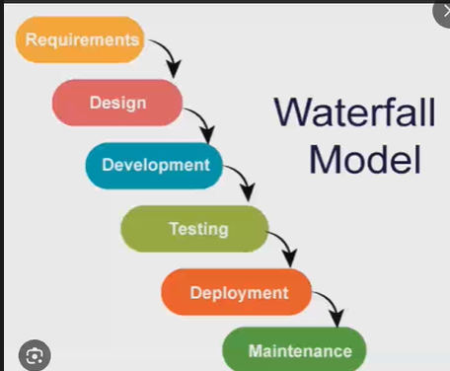

- Agile methodology – Quick delivery
Split the task among workers to complete the product early.
There are 3 roles:
- Product owner
- Scrum master
- Development Team
There will be different meeting and reviews.

DAY 5 – 06/02/2026 API
An async function is a function that can run without blocking other tasks while waiting for operations like:
- database queries
- API calls
- file reading
- network requests
This line is used to import the FastAPI class so we can build an API.
POSTMAN – It is used to test the API
Backend: The part of an application that works behind the scenes to handle logic, database operations, and user requests.
API: A system that allows different applications (frontend and backend) to communicate with each other.
Flask: A simple and lightweight Python framework used to create web applications and APIs.
FastAPI: A fast and modern Python framework designed for building efficient and high-performance APIs.
Route: A specific URL endpoint that connects a web request to a function in the backend.
Request: Information sent by the client (like browser or app) to the server.
Response: The reply sent back from the server to the client.
JSON: A structured text format used to send and receive data between systems.
HTTP GET: A request method used to retrieve data from a server.

Assignment 1

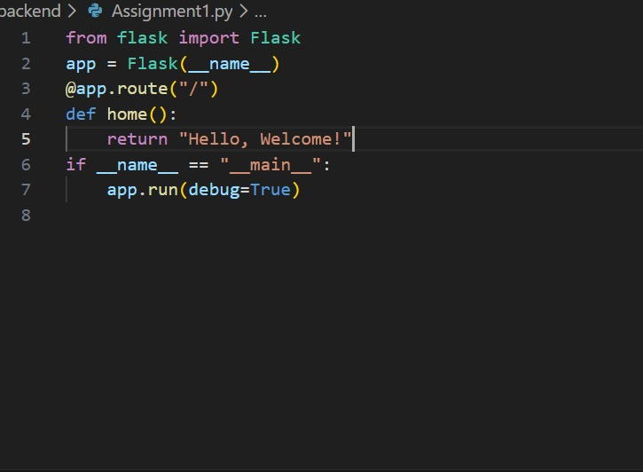
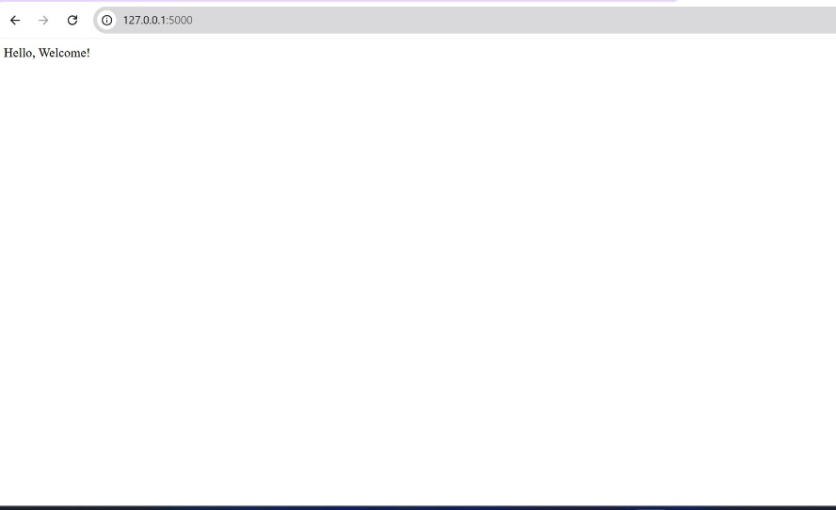

DAY 6– 07/02/2026 SQL
- CREATE – Used to create a new database or table.
Example: CREATE TABLE students (...);
- INSERT – Used to add new data into a table.
Example: INSERT INTO students VALUES (...);
- SELECT – Used to retrieve (fetch) data from a table.
Example: SELECT * FROM students;
- UPDATE – Used to modify existing data in a table.
Example: UPDATE students SET name='Abi' WHERE id=1;
- DELETE – Used to remove data from a table.
Example: DELETE FROM students WHERE id=1;
- WHERE – Used to filter records based on a condition.
Example: SELECT * FROM students WHERE age > 18;
- ALTER – Used to modify table structure (add/remove columns).
Example: ALTER TABLE students ADD email VARCHAR(100);
- DROP – Used to delete a table or database completely.
Example: DROP TABLE students;

JOIN operations
- SQL JOIN Operations
SQL JOIN is used to combine data from two or more tables using a common column.
1.1 INNER JOIN
INNER JOIN returns only the rows that have matching values in both tables.
Example:
SELECT students.name, marks.score
FROM students
INNER JOIN marks ON students.student_id = marks.student_id;
1.2 LEFT JOIN
LEFT JOIN returns all records from the left table and matching records from the right table. If there is no match, NULL values are shown for the right table.
Example:
SELECT employees.name, departments.department_name
FROM employees
LEFT JOIN departments ON employees.dept_id = departments.dept_id;
1.3 RIGHT JOIN
RIGHT JOIN returns all records from the right table and matching records from the left table. If there is no match, NULL values are shown for the left table.
Example:
SELECT customers.customer_name, orders.order_date
FROM customers
RIGHT JOIN orders ON customers.customer_id = orders.customer_id;
1.4 FULL JOIN
FULL JOIN returns all records from both tables. If there is no match, NULL values appear for the missing side.
Example:
SELECT teachers.name, subjects.subject_name
FROM teachers
FULL JOIN subjects ON teachers.subject_id = subjects.subject_id;
Assignment 2
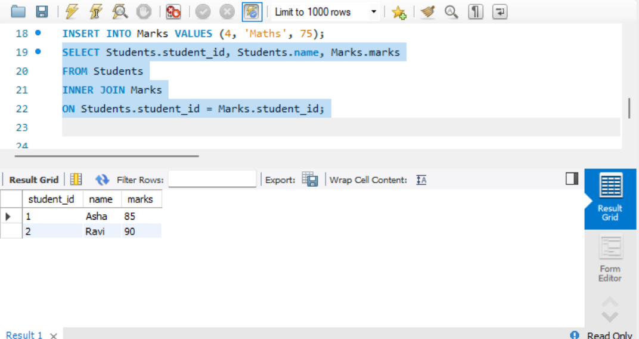
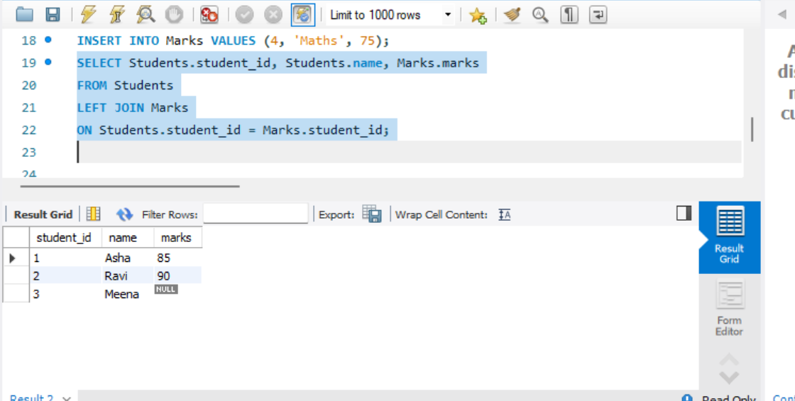
DAY 7 JWT (JSON Web Token)
Introduction to JWT (JSON Web Token)
JWT (JSON Web Token) is a secure way to send information between two systems in the form of a JSON object. It is mainly used for user authentication and authorization in web applications.
2.1 Structure of JWT
A JWT has three main parts:
- Header – Stores the type of token and the encryption algorithm used.
- Payload – Contains user information and claims.
- Signature – Verifies that the token has not been changed.
2.2 Generating JWT in Python
Steps to create a JWT using PyJWT:
- Install the library: pip install PyJWT
- Import jwt and datetime modules.
- Create a secret key.
- Prepare the payload with user data.
- Add expiration time.
- Encode the payload to generate the token.
Example Code:
import jwt
import datetime
key = "secret123"
data = {
"username": "abi",
"role": "user",
"exp": datetime.datetime.utcnow() + datetime.timedelta(minutes=30)
}
jwt_token = jwt.encode(data, key, algorithm="HS256")
2.3 Advantages of JWT
- No need to store session data on the server (stateless).
- Secure and easy verification using signature.
- Can be used across different services and applications.

DAY 8 Hashing & Password Security
Hashing: A technique that converts input data into a fixed-length output using a mathematical algorithm.
Example: hash("data")
Password Hashing: Securing a password by converting it into an unreadable format before saving it in a database.
Example: bcrypt.hashpw(b"1234", bcrypt.gensalt())
Hashed passwords cannot be converted back to the original password because hashing is a one-way process.
Encoding: A reversible process that changes data into another format for storage or transmission.
Example: "hello".encode()
Encryption: A reversible method that protects data using a secret key.
Bcrypt: A strong and secure algorithm used specifically for password hashing.
Salt: A randomly generated value added to a password before hashing to increase security.
gensalt(): A function in bcrypt that creates a random salt value.
Example: bcrypt.gensalt()
bcrypt.hashpw(): A function that hashes a password along with a salt.
String to bytes: Required because bcrypt works with byte-type data instead of normal strings.
Example: b"password"
String Built-in Methods (One Line + Input/Output)
strip(): Removes spaces from the beginning and end of a string.
Input: " test " → Output: "test"
join(): Combines elements of a list into a single string.
Input: " ".join(["Good","Morning"]) → Output: "Good Morning"
replace(): Replaces a part of a string with another value.
Input: "apple".replace("a","m") → Output: "mpple"
startswith(): Checks whether the string starts with a specific value.
Input: "python".startswith("py") → Output: True
endswith(): Checks whether the string ends with a specific value.
Input: "python".endswith("on") → Output: True
find(): Returns the index of the first occurrence of a substring.
Input: "python".find("t") → Output: 2
isdigit(): Checks if all characters are numbers.
Input: "456" → Output: True
isalpha(): Checks if all characters are letters.
Input: "code" → Output: True
Dictionary Methods (One Line + Input/Output)
get(): Retrieves the value of a specified key.
Input: {"city":"Chennai"}.get("city") → Output: "Chennai"
keys(): Returns all keys in the dictionary.
Input: {"x":10,"y":20}.keys() → Output: dict_keys(["x","y"])
values(): Returns all values in the dictionary.
Input: {"x":10,"y":20}.values() → Output: dict_values([10,20])
items(): Returns key-value pairs.
Input: {"x":10}.items() → Output: dict_items([("x",10)])
update(): Adds or modifies dictionary entries.
Input: d.update({"z":30}) → Output: Dictionary updated
pop(): Removes a key and returns its value.
Input: {"x":10}.pop("x") → Output: 10
popitem(): Removes and returns the last inserted key-value pair.
Input: {"a":1,"b":2}.popitem() → Output: ("b",2)
clear(): Removes all elements from the dictionary.
Input: {"x":10}.clear() → Output: {}
Set Methods & Operations (One Line + Input/Output)
add(): Adds a new element to the set.
Input: {5,6}.add(7) → Output: {5,6,7}
remove(): Removes a specified element (error if not found).
Input: {5,6,7}.remove(7) → Output: {5,6}
discard(): Removes an element safely without error.
Input: {5,6}.discard(8) → Output: {5,6}
pop(): Removes and returns a random element.
Input: {5,6}.pop() → Output: 5 or 6
clear(): Deletes all elements from the set.
Input: {5,6}.clear() → Output: set()
union(): Combines two sets without duplicates.
Input: {5,6}.union({6,7}) → Output: {5,6,7}
intersection(): Returns common elements from both sets.
Input: {5,6}.intersection({6,7}) → Output: {6}
difference(): Returns elements present in first set but not in second set.
Input: {5,6}.difference({6,7}) → Output: {5}
DAY-9 WORKING ON PROJECT
DAY-10 MILESTONE
DAY-11 MILESTONE
DAY-12 MILESTONE
DAY-13 INPUT AND OUTPUT METHOD
Open()-to open the file
read() – Reads entire file content from top to bottom
readline() – Reads one line at a time-particular line
readlines() – Reads all lines as a list(From one line to another)
write() – Writes data into file
writelines() – Writes multiple lines into file
close() – Closes the file
len()-length of the particular variable
id()-returns the unique memory address of an object
range()-Generates a sequence of numbers
print()-prints the output
type()-returns the datatype of a value
ex: a=”9” type(a)
sorted() – Returns a sorted list
enumerate() – Returns index and value pairs
zip() – Combines multiple iterables into pairs
conversion function-its useful in big programming
int() → Converts a value into an integer
✔ Example: int("10") → 10
float() → Converts a value into a decimal number
✔ Example: float("5.5") → 5.5
str() → Converts a value into a string (text)
✔ Example: str(100) → "100"
list() → Converts a collection into a list
✔ Example: list((1,2,3)) → [1,2,3]
dict() → Converts paired data into a dictionary (key-value)
✔ Example: dict([(1,"a"), (2,"b")]) → {1:"a", 2:"b"}
set() → Converts data into a set (unique values)
✔ Example: set([1,1,2,3]) → {1,2,3}
tuple() → Converts a collection into a tuple (fixed list)
✔ Example: tuple([1,2,3]) → (1,2,3)
Mathematical function:value into positive integer
abs() → Gives the positive value of a number
✔ Example: abs(-10) → 10
sum() → Adds all values in a list/tuple
✔ Example: sum([1,2,3]) → 6
min() → Finds the smallest value
✔ Example: min(5, 2, 9) → 2
max() → Finds the largest value
✔ Example: max(5, 2, 9) → 9
pow() → Gives the power of a number
✔ Example: pow(2, 3) → 8
round() → Rounds a number to the nearest value
✔ Example: round(4.6) → 5
Class and objects:
getattr() → Gets the value of an object’s attribute
✔ Example: getattr(obj, "name")
setattr() → Sets or updates an attribute value
✔ Example: setattr(obj, "age", 20)
hasattr() → Checks whether an attribute exists or not
✔ Example: hasattr(obj, "name") → True/False
delattr() → Deletes an attribute from an object
✔ Example: delattr(obj, "age")
isinstance() → Checks whether an object is of a specific class
✔ Example: isinstance(10, int) → True
issubclass() → Checks whether a class is a child of another class
✔ Example: issubclass(B, A) → True
isinstance(object, class/type)
→ Checks whether an object is an instance of a class, data type, or its subclass.
✔ Example:
isinstance(10, int) → True
And for comparison:
issubclass(child, parent)
→ Checks whether one class is a subclass of another class.
✔ Example:
issubclass(bool, int) → True
enumerator()-assignment3a
Exceptional handling-assignment-3b
difference between if-else and exceptional handling
Memory and object management
del() → Deletes a variable or object from memory
✔ Example: del x
gc.collect() ✅ (correct spelling, not gc.collet)
→ Forces garbage collection to free unused memory
✔ Example:
import gc
gc.collect()
gc collections memory an automatic memory management process in computer programming that identifies and deletes objects no longer in use, reclaiming memory for future, active data.
eval() → Evaluates and runs a single expression
✔ Example: eval("10+5") → 15
exec() → Executes a block of Python code
✔ Example: exec("a=5\nb=6\nprint(a+b)") → 11
Enumerator: reduces or decreases number of iteration.
enumerate()is a built-in function in Python that adds a counter (index) to an iterable (like a list, tuple, or string).
It returns both: Index and value
Assignment 3a
names = ["Abi", "Vaishu", "Priya"]
for index, value in enumerate(names):
print(index, value)
output:
0 Abi
1 Vaishu
2 Priya
gc library-The gc module is a garbage collector which is a built in module in python.
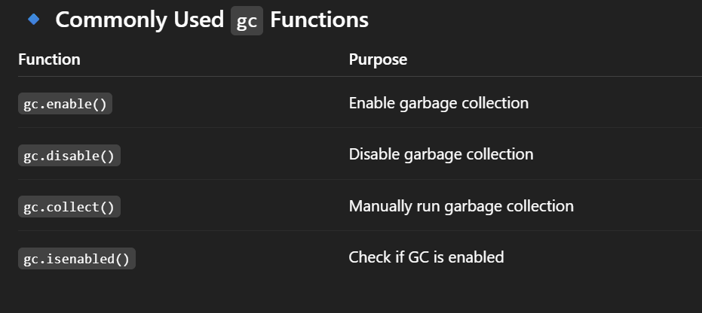
Assignment 3b
x = 10
print(isinstance(x, int))
print(isinstance(x, str))

DAY-13 LLM Large Language Model
AI Models-AI model is a program that is trained to recognize patterns and make decisions using data.
Google-Gemini models
OpenAi-Chatgpt
Microsoft → Copilot, Azure OpenAI services
Groq → Ultra-fast inference hardware + LLMs
NLP- It is a field of AI that deals with understanding and processing human language.
LLM – It is a type of model inside NLP
Google AI studio
Rate limit and token limit
Rate limit is request count-how many request sent to server or API
Token limit is Text and word count. Input and output both are calculated.

response = client.chat.completions.create(
model="gpt-4o-mini",
messages=messages,
temperature=0.7,
max_tokens=500
pip install openai
import openai

DAY 14 NLTK (Natural Language Toolkit)
- from nltk.tokenize import word_tokenize –
- word_tokenize() is used to split a sentence into individual words (tokens).
Ex: "I love AI" → ["I", "love", "AI"]
- from nltk.corpus import stopwords - Stopwords are common words like is, the, in, and which do not add much meaning.
- from nltk.stem import PorterStemmer - PorterStemmer reduces words to their root/base form (called stemming).
Ex: "playing" → "play"
"studies" → "studi"
- from nltk.stem import WordNetLemmatizer - Lemmatizer converts a word into its meaningful base form (lemma).
Ex: "better" → "good"
"running" → "run"
- nltk.download('words') - Downloads English word database.
- nltk.download('maxent_ne_chunker') - Downloads Named Entity Recognition model (used to identify names of persons, places, organizations).

ASSIGNMENT 4
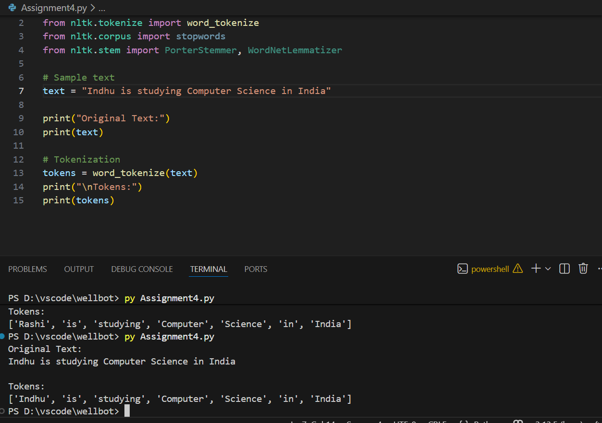
DAY 15 MACHINE LEARNING
It is a subset of AI. It learns from the data and dataset. There are 3 main types of ML
- Supervised learning -It uses labelled data. They know input and output. There are 2 main types.
- Regression: Continuous prediction
- Classification: it is used when the output is a category or label
- Unsupervised learning –learns from unlabelled data.
Eg: customer grouping
Clustering: It groups the similar characteristics.
- Reinforcement-learns by trial and error.
Gets rewards and penalty
Eg: training a robot

Embedding conversion of text, images or words to numbers(vectors).
Easier for comp and AI models.

Use cases:
Recommendation
Logistic Regression: it is a supervised machine learning classification algorithm used to predict the binary outcomes like 0 or 1, yes or no, True or False.
It uses the Sigmoid function to convert output into a probability between 0 and 1.
Key formula:
Final Prediction Rule:
If y>=0.5 class=1
If y<0.5 class=0

SK learn-it is a python library. It is provided by scikit-learn
From sklearn.linear_model import LogisticRegression
It provides tools like:
Classification, regression clustering data preprocessing etc.
It helps to build machine learning models easily without writing complex algo.

Decision Tree: also a supervised ML algo used for classification and regression that makes decisions using tree-like structure.

It has 3 main types:
- Root Node
- Internal node
- Leaf node
